Lyotropic/chromonic liquid crystals based on transition metal complexes

Elisabeta I. Szerb¹, Carmen Cretu¹, Zoltán Dudas², Adél Len²

¹”Coriolan Drăgulescu” Institute of Chemistry, Romanian Academy, 24 Mihai Viteazu Bvd., 300223-Timişoara, ROMANIA
²Neutron Spectroscopy Department/Wigner Research Centre for Physics, Konkoly-Thege 29-33, 1121 Budapest, Hungary
³Nuclear Analysis and Radiography Department/Centre for Energy Research, Konkoly-Thege 29-33, 1121 Budapest, Hungary
⁴Faculty of Engineering and Information Technology/University of Pécs, Boszorkány út 2, 7624 Pécs, Hungary

Lyotropic liquid crystals are fascinating materials with extensive practical applications in cosmetics, pharmaceutics and the soap and detersive industry. Moreover, future attractive applications in other important domains like energy, biology and medicine are foreseen [1]. The latter is basically due to the tendency of modern science to imitate and learn from nature, in fact several biological structures, ranging from proteins and nucleic acids to viruses and cell membranes are organized and function in lyotropic liquid crystalline organizations in nature [2]. Understanding self-assembly in simpler systems may bring help elucidating mechanism of self-assembly in complex living systems.
While self-assembly of the classical surfactants can be quite well described by mathematical models, the mechanism for chromonic lyotropy has not yet been elucidated [3]. Chromonics are a sub-class of lyotropic liquid crystals although have distinct molecular structures and mesophase properties. They are usually flat organic molecules having planar aromatic π – delocalized cores surrounded by solubilising/charged groups which aggregate into columnar structures in water (isodesmic aggregation) [4]. Moreover, they exhibit typical birefringent textures in Polarized Optical Microscope. Their X-Ray diffraction patterns exhibit relatively strong reflection centered at 3.3 Å, a typical distance of π−π bonded adjacent molecules inside the columnar structures.
Recently some transition metal complexes have been reported to exhibit lyotropic/chromonic liquid crystalline mesophases in water – contravening the structural rules formulated for the classical organic chromonics. These are Pt(II) arrow-shaped [5], Ag(I) star-like [6] and octahedral Ir(III) coordination complexes [7]. SAXS and SANS analysis of the latter revealed a two-dimensional arrangement, with a columnar rectangular symmetry. Thus, the following self-assembly model (Figure 1) was proposed:
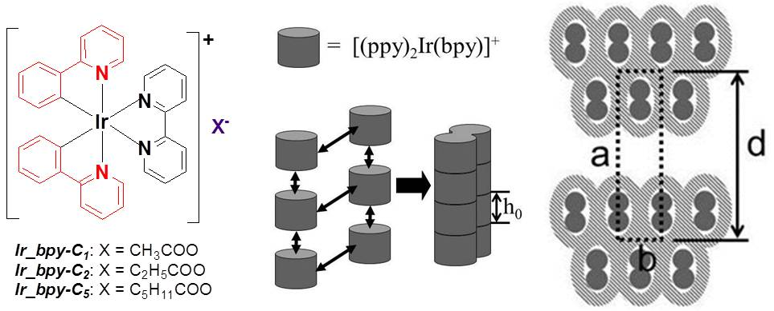
Figure 1. Left: structure of Ir(III) coordination complexes; middle: in water, complexes self-associate into twin polyelectrolyte strings (strands, solid grey); right: the strands associate laterally into double-rows incorporating water and counter-ions (grey hatched). The rejection of excess water (not represented) between double rows gives rise to a lamellar periodicity (of distance d); the registry between double-rows leads to a columnar superstructure (indicated by a dotted rectangle). The orientation of strands in double-rows is not known and is arbitrarily chosen for representation.

Our aim was to extend the class of lyotropic/chromonic liquid crystals based on transition metal complexes. Here we studied the influence of the different molecular units on self-assembly in water by a molecular engineering approach. Thus, the metal, the coordinating and/or cyclometallating ligands and counterions were gradually modified/replaced and self-assembly in water was studied by polarized optical microscopy, SAXS, SANS, rheology and NMR. The talk will focus on the neutron diffraction studies of new Rh(III) complexes, structural analogues of the previously reported Ir(III) complexes, by which their mesomorphic properties in water were determined. The new complexes constitute a new class of chromonics or, eventually, a new class of materials.
Bibliography:
[1] R. Mezzenga, J. M. Seddon, C. J. Drummond, B. J. Boyd, G. E. Schröder-Turk, L. Sagalowicz, Adv. Mater. 2019, 1900818.
[2] J. Zhao, U. Gulan, T. Horie, N. Ohmura, J. Han, C. Yang, J. Kong, S. Wang, B. B. Xu, Small 2019, 1900019.
[3] A. Masters, Liq. Cryst. Today 2016, 25(2), 30.
[4] J. Lydon, J. Mater. Chem. 2010, 20, 10071.
[5] Q. Gao, C. Zou, W. Lu, Chem. Asian J. 2018, 13, 3092.
[6] D. Pucci, B. Sanz Mendiguchia, C. M. Tone, E. I. Szerb, F. Ciuchi, M. Gao, M. Ghedini, A. Crispini, J. Mater. Chem. C 2014, 2(41), 8780.
[7] Y. J. Yadav, B. Heinrich, G. De Luca, A. M. Talarico, T. F. Mastropietro, M. Ghedini, B. Donnio, E. I. Szerb, Adv. Optical Mater. 2013, 1, 844; C. Oliviero Rossi, C. Cretu, L. Ricciardi, A. Candreva, M. La Deda, I. Aiello, M. Ghedini, E. I. Szerb, Liq. Cryst. 2017, 44(5), 880.

