scientificamerican.com

Voyager 2 Makes an Unexpectedly Clean Break from the Solar System
Jonathan O'Callaghan
5-6 perc

The first scientific results from the spacecraft’s exit into interstellar space have been published, revealing a simpler departure than its predecessor
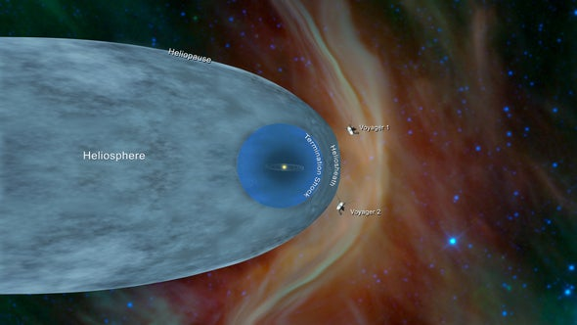
Illustration shows the positions of NASA’s Voyager 1 and Voyager 2 probes outside the heliosphere, the region surrounding our star, beyond which interstellar space begins. Credit: NASA and JPL-Caltech
Astronomers have released the first results from the late 2018 passage of NASA’s Voyager 2 probe into interstellar space, revealing some notable differences to the first crossing made by its sister spacecraft, Voyager 1, in 2012. The data shows that although Voyager 1’s departure was fairly “messy,” the exit of Voyager 2 was much cleaner as it left our sun’s influence on its journey into the galaxy.
Using data from Voyager 2’s Plasma Science Experiment, an instrument that was not working on Voyager 1 during its earlier entry into interstellar space, scientists confirmed that Voyager 2’s exit occurred on November 5, 2018. That was when Voyager 2 registered a sudden decrease in the “solar wind” particles emanating from our sun, along with a concordant increase in the numbers of incoming galactic cosmic rays and the strength of the interstellar magnetic field. Taken together, these data showed the spacecraft had passed beyond a boundary of our sun’s influence known as the heliopause—loosely defined as the point at which interstellar space begins. Both of the Voyager probes were launched weeks apart in 1977 on a grand tour of the outer planets, and to date are the only human-built machines to have reached interstellar space.
In a series of papers published in the journal Nature Astronomy, five separate teams of scientists analyzed the data from Voyager 2 to compare its crossing with that of Voyager 1. Although it took Voyager 1 about 28 days to cross the heliopause after leaving the sun’s bubble of influence, known as the heliosphere, it took Voyager 2 less than a day to do so. “On Voyager 1 we found that even before we left the heliosphere we had two episodes where we were connected to the ‘outside,’” says Voyager project scientist Ed Stone, lead author on one of the papers. “On Voyager 2 it was just the opposite. We were outside, but we continued to see particles leaking from the inside.”
The passage of the two spacecraft into interstellar space occurred at similar distances from the sun—121.6 AU for Voyager 1 versus 119 AU for Voyager 2 (one AU, or astronomical unit, is the distance from Earth to the sun). But Voyager 1 appears to have been unique in crossing a so-called stagnation region, 8.6 AU across, where the movement of plasma around the spacecraft dropped to almost zero (scientists were able to work this out from other instruments, despite the spacecraft not having a working plasma instrument). “Essentially the plasma was just sitting there,” says John Richardson from the Massachusetts Institute of Technology, lead author on another paper.
By comparison, Voyager 2 did not encounter a region where the plasma stagnates, instead passing through a so-called transition region where the flow of plasma from the sun begins to change in strength and direction, followed by a “boundary layer” where incoming cosmic ray particles increase, and then a clean break through the heliopause. “Voyager 1 seemed to be more messy,” says Du Toit Strauss of North-West University in South Africa. “Voyager 2 had this seemingly more simple structure, and that’s not explained at the moment. It might be due to [decreased solar activity during the sun’s 11-year solar cycle], and Voyager 2 was crossing when the heliopause was moving inwards.”
Nevertheless, despite the spacecraft being separated from each other by 165 AU, the fact that the two crossings occurred at similar distances during significantly different levels of solar activity was “remarkable,” Stamatios Krimigis of Johns Hopkins University and his colleagues wrote in their own paper. And the overall results pose some interesting questions about the possible structure of the heliosphere, with some debate as to whether it is a spherical bubble or more cometlike, with a tail extending back owing to the sun’s motion through the galaxy. “It seems to be something in between,” Strauss says. “We don’t know the exact shape of our heliosphere, which is rather depressing.”
Both Voyager 1 and Voyager 2 crossed into interstellar space at the supposed “head” of this comet, so it would take a mission in the other direction to work out if there is indeed a tail. Scientists have been discussing the possibility of sending out a new interstellar probe, although such a mission would probably launch no sooner than the 2030s. Until then, humanity’s two intrepid interstellar travellers will continue to define our current understanding. And with the possibility the probes could live for another decade, scientists are looking forward to further measurements they make deeper in interstellar space.

ABOUT THE AUTHOR(S)

Jonathan O'Callaghan
Jonathan O'Callaghan is a freelance journalist covering commercial spaceflight, space exploration, astrophysics, and a wide range of science.

