Dr. Mrityunjay Singh

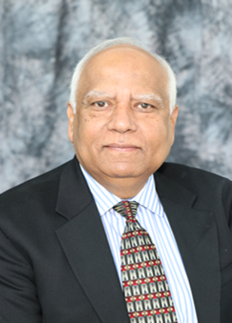

Biography
Dr. Mrityunjay Singh is Chief Scientist at Ohio Aerospace Institute in Cleveland, OH. He served as President of the American Ceramic Society during 2015-16 and currently serves as President of the World Academy of Ceramics, Italy (2018-22). He is a Governor of Acta Materialia, Inc., Academician of World Academy of Ceramics, and Fellow of ACerS, ASM International, AAAS, and NAI. He has received honorary doctorates from Nagaoka University of Technology, Japan and Slovak Academy of Sciences, Slovakia. He is recipient of more than eighty national and international awards including four R&D 100 awards, FLC Technology Transfer Award, NASA Public Service Medal, NASA Silver Snoopy Award, W.D. Kingery Award, John Jeppson Award, Richard M. Fulrath Award, President Award, and James I Mueller Award from American Ceramic Society; Sir Richard Brook Award and Honorary Fellowship from European Ceramic Society; Ishikawa International Carbon Prize and JFCA International Prize from Japan; Jacques-Lucas Award from ASM International-IMS, Distinguished Engineering Achievement Award from Engineers Council, International Dresden Barkhausen Award from Germany, Distinguished Alumnus Award from IIT-BHU, Varanasi and Keramos Award from Poland. He has been awarded many honorary and distinguished life memberships/ fellowships and honorary professorships from all over the world. Dr. Singh is editor/co-editor of fifty five books and proceedings, seven special journal volumes, author/co-author of fourteen book chapters, and more than two hundred seventy five papers in various journals and proceedings. He has delivered numerous keynote and plenary presentations in international conferences, forums, and workshops, and serves on the advisory boards and committees of more than fifteen prestigious international journals and technical publications.

Materials and Integration Technologies for Alternative and
Renewable Energy Systems:
Technical Challenges and Opportunities

Prof. Dr. Dr.h.c.mult. M. Singh
Past President, The American Ceramic Society
President, World Academy of Ceramics, Italy
President, Global Alliance for Technology and Society
Governor, Acta Materialia, Inc.
Chief Scientist, Ohio Aerospace Institute, OH (USA)

Abstract

Global energy demand is projected to sharply rise over the next several decades. Future energy production systems must be sustainable, environmentally conscious, and less reliant on conventional fossil fuels that are associated with a massive carbon footprint. Advanced ceramic materials and multiscale ceramic integration technologies will dramatically impact the energy and environment landscape due to their wide scale applications in all aspects of alternative and renewable energy production, storage, distribution, conservation, and efficiency. Examples include fuel cells, thermoelectrics, gas turbine systems, distribution and transmission systems based on superconductors, nuclear power generation, NOx and COx reduction technologies, and a wide variety of green and energy efficient manufacturing processes and technologies. Affordable and reliable solar energy technologies could also play key role in sustainable development around the globe without major impact on environment since solar power is a clean, renewable, and sustainable energy source. However, revolutionary approaches for thermal energy storage (TES) system at elevated temperatures (>700 ˚C) for concentrated solar power (CSP) are needed for reliable energy supply. Integration technologies are key to making these systems a reality. In this presentation, various challenges and opportunities in design, fabrication, and testing of integrated systems will be discussed. Specific examples will be given for integration of fuel cell systems, thermal management, and thermal energy storage devices. Potential opportunities and need for the development of innovative design philosophies, approaches, and integrated system testing under simulated conditions will also be discussed.

