Infrastructure
OPEN INTERNATIONAL GRANT COMPETITION OF NATIONAL UNIVERSITY OF SCIENCE AND TECHNOLOGY «MISIS» DESIGNED TO PROVIDE SUPPORT TO A RESEARCH PROJECTS IMPLEMENTED UNDER THE SUPERVISION OF LEADING SCIENTISTS 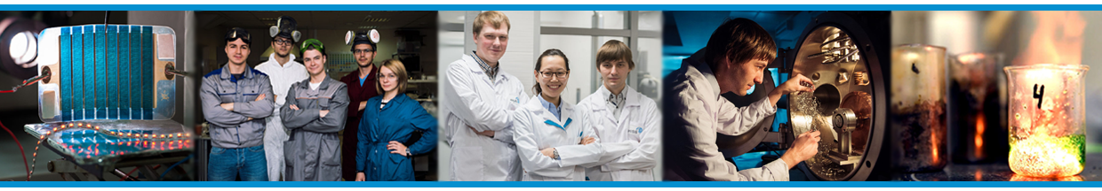
OBJECTIVES
- Development of the existing research area
- Increase of the publication activity
- Attraction of the Leading scientists
- Creation of the competitive environment for scientific research activity
- Creation of the new educational course and/or the master’s course based on the prospective research area
- Increase of the quantity of oral reports at the international conferences and seminars
- Attraction of the new generation of the Young scientists

DURATION
- 1,5 years with the possibility of being renewed based on the results of the previous work.
(01.07.2017 – 31.12.2018)

RESEARCH AREAS:
- Meta-materials and post-silicon electronics, materials design
- Autonomous energy and energy efficiency
- Materials and technologies for improving human lifespan and overall quality of life
- Industrial design and engineering technologies to reindustrialise the economy
- Green technologies for efficient resource use
FUNDING up to 20 mln. rubles for
- Research team salary (including extra charges)
- International conferences (oral reports)
- Research equipment parts and supplies costs
- Research equipment purchase costs

OBLIGATIONS
- Presence of the Leading scientist in MISiS for the direct supervision of the research project
and the laboratory for at least 2 months (in total) in 2017; 4 months (in total) in 2018
- Publication activity (the peer review journals referenced in the «Web of Science»)
- New educational course in the new research area
К2

DEADLINE for applications: 22th of May, 2017
Learn more about Infrastructure Program:
http://science.misis.ru/en/top100/konkurs/
National University of
Science and Technology «MISiS»
4 Leninsky prospect
119049, Moscow
Help and assistance:
E-mail: projects@misis.ru
Tel. +7495 638 46 29
www.science.misis.ru/en
http://www.misis.ru/en/

International Research Projects Department

